E-Commerce Data Analytics Project Documentation
- Project Title: E-Commerce Data Analytics phyton
- Developed By: Krishna kumar S

1.Project Overview
This project aims to analyze e-commerce transaction data to gain insights into customer behavior, sales trends, and product popularity. The project also involves customer segmentation to identify different customer groups for business strategies.

2.Dataset Information
- Source: E-commerce transaction data
- Columns:
  - CustomerID
  - Products
  - OrderDate
  - Spend

1. Data Cleaning
- Loaded the dataset using Pandas.
- Handled missing values:
  - Dropped or imputed null CustomerID or Spend.
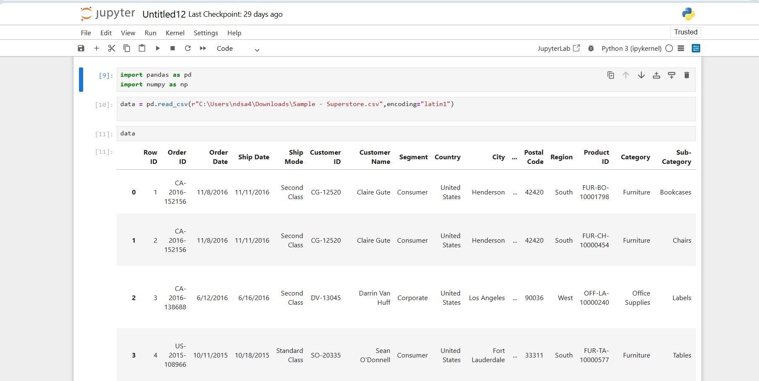
- Formatted OrderDate to datetime format.

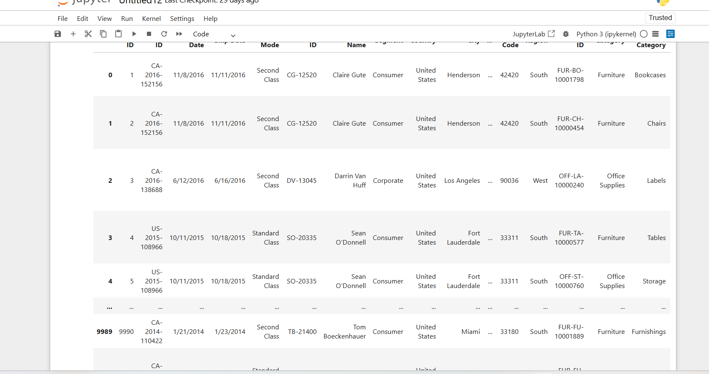
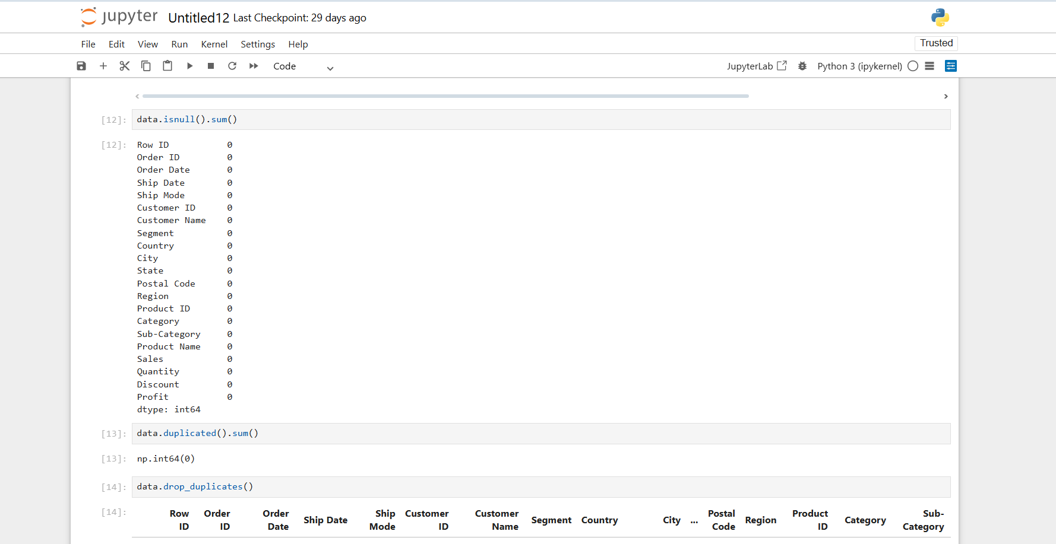
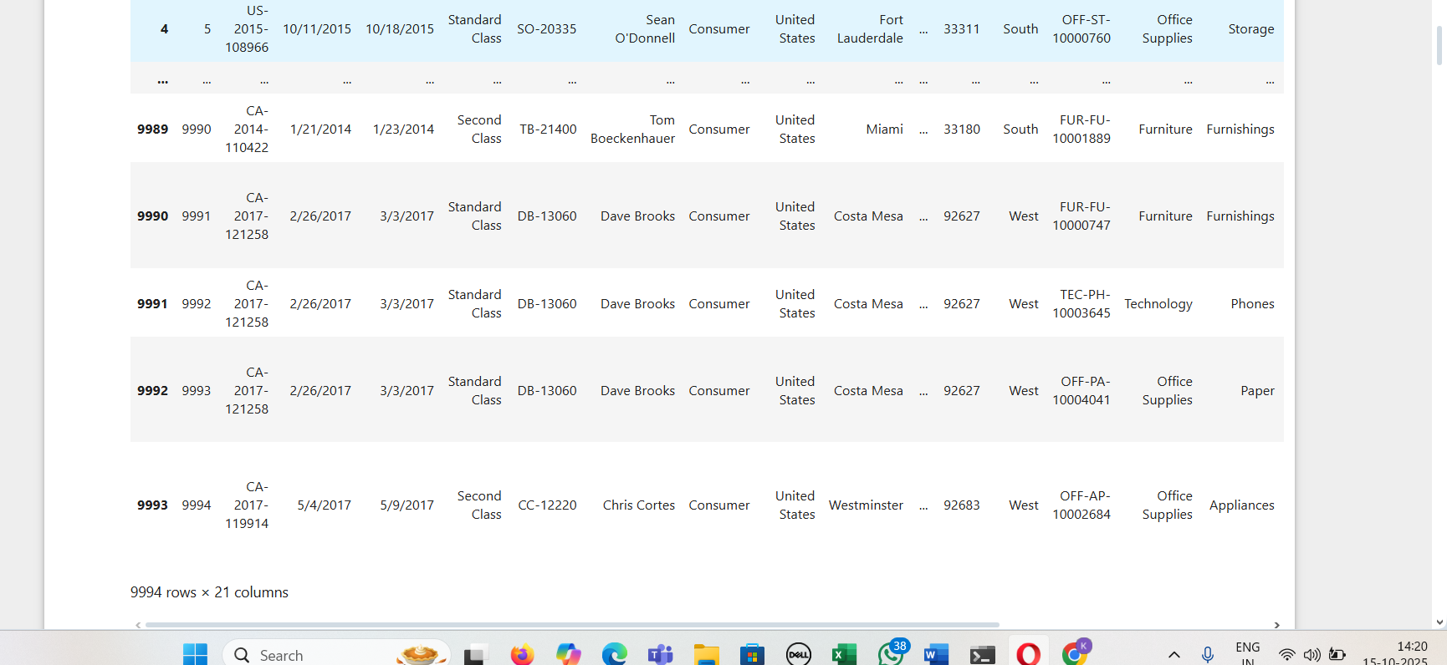

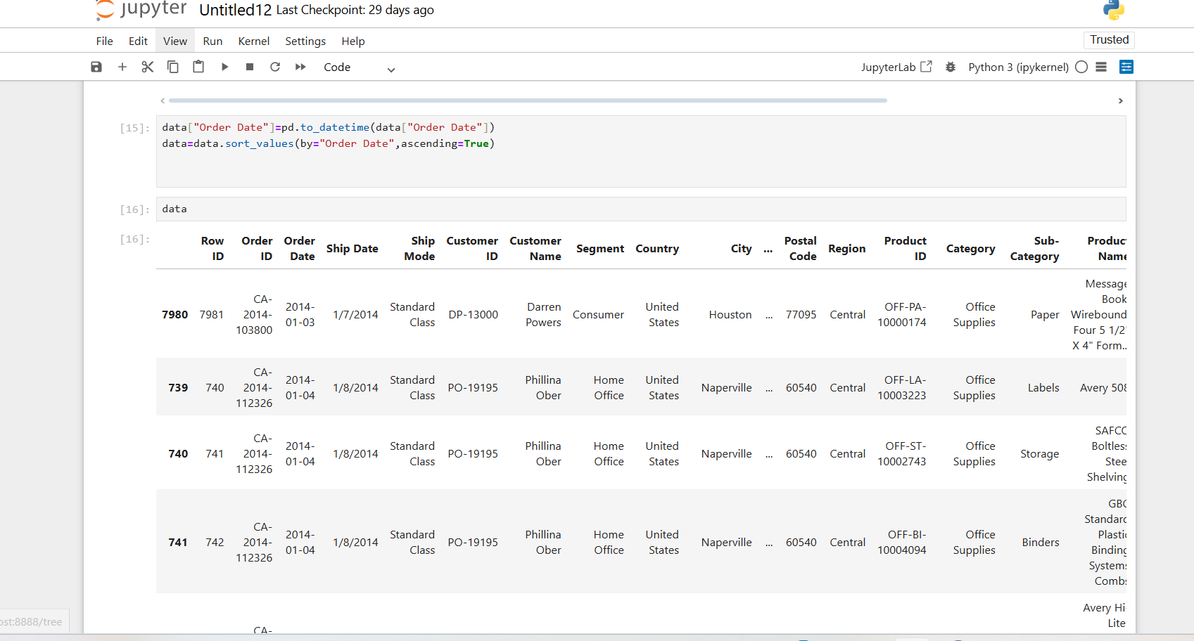
2. Exploratory Data Analysis (EDA)
- Analyze:
  - Total spend
  - Top customers
  - Popular products
- Use Matplotlib and Seaborn for visualizations:
  - Sales trends
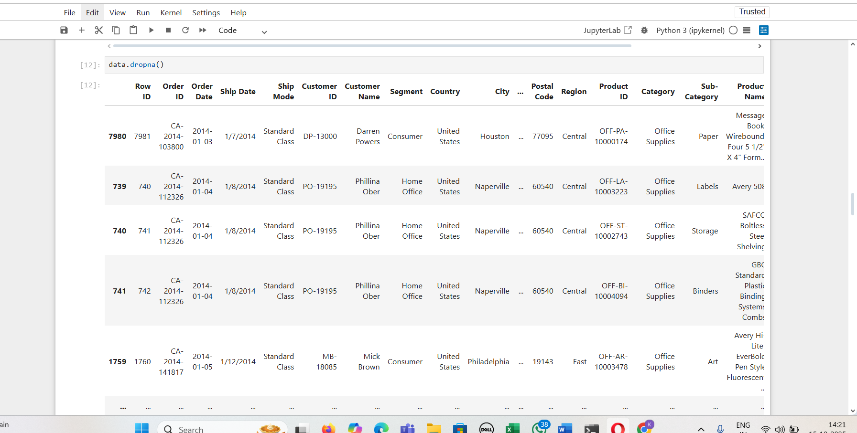
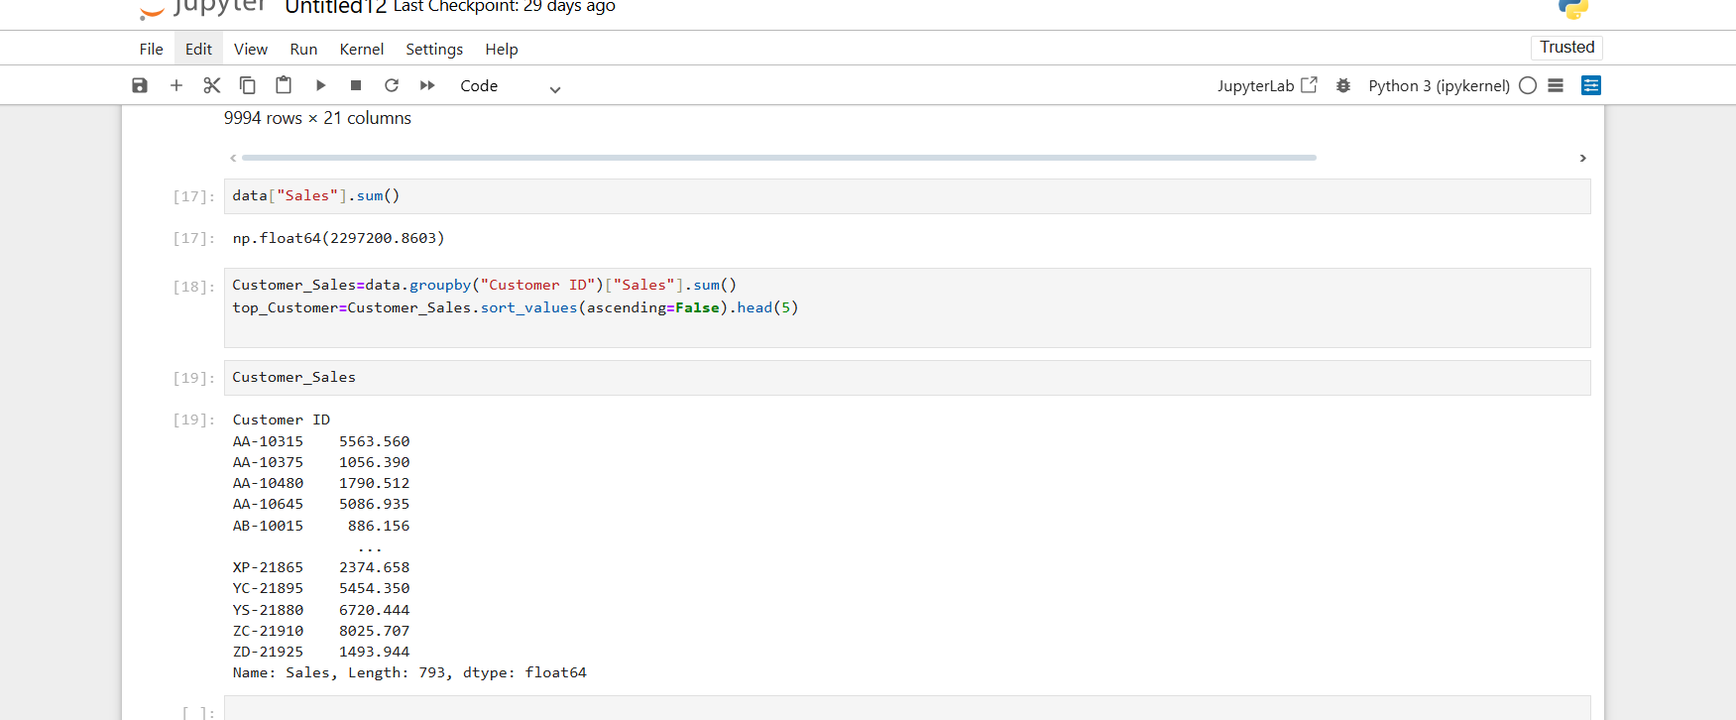
  - Customer patterns
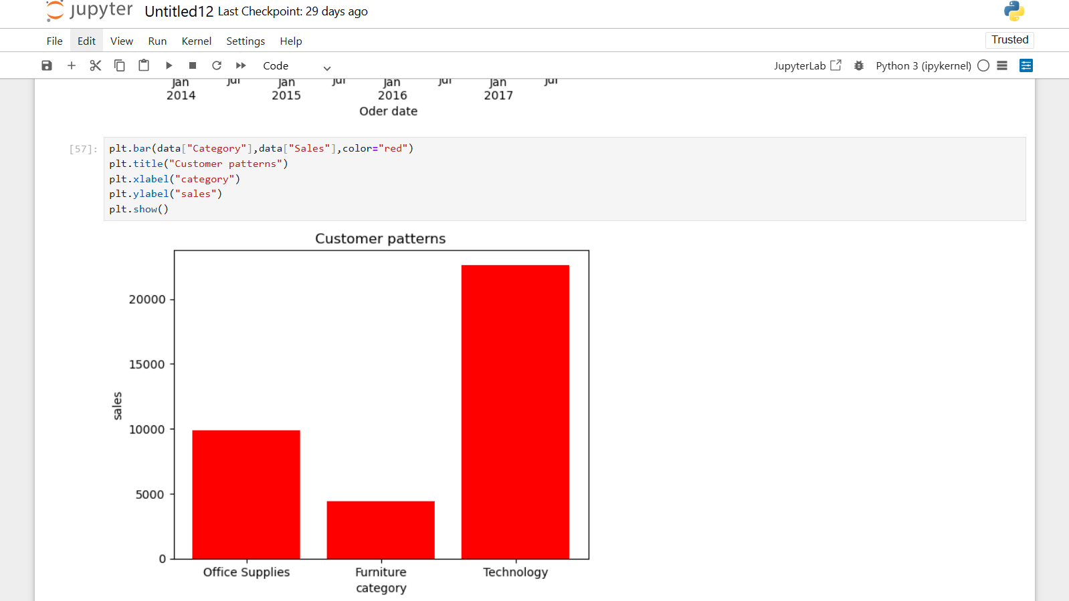
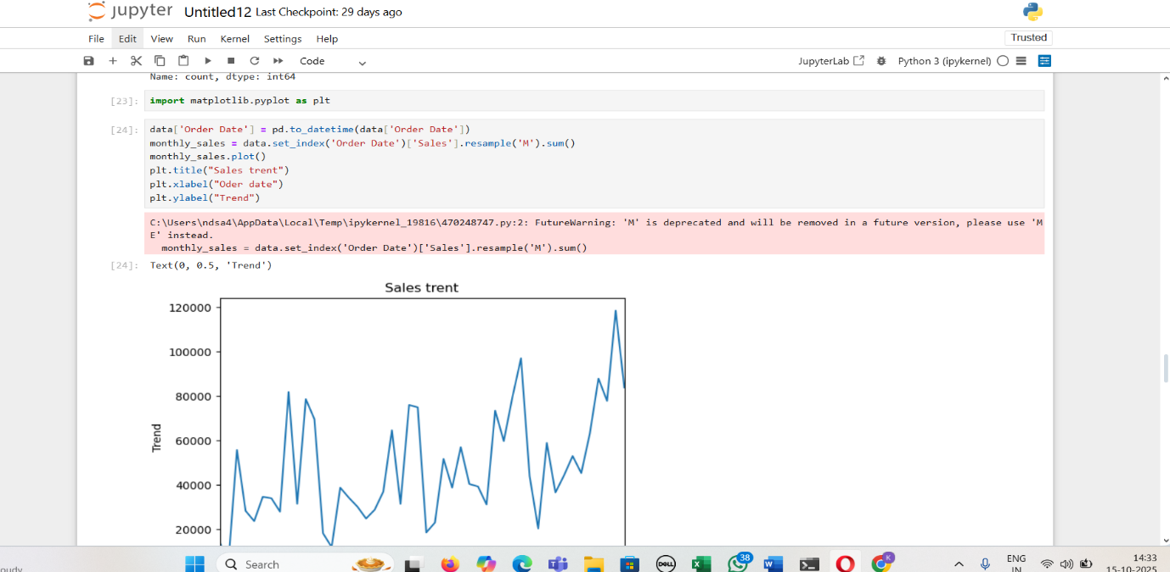
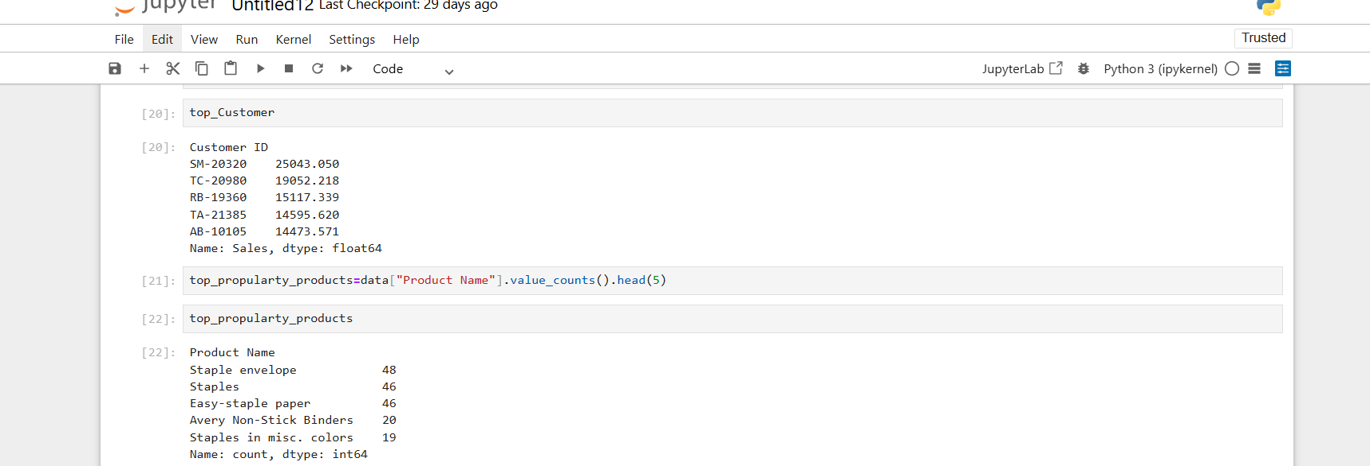

3. Customer Segmentation
- Define customer types:
  - High Value
  - Regular
  - One-time Buyers
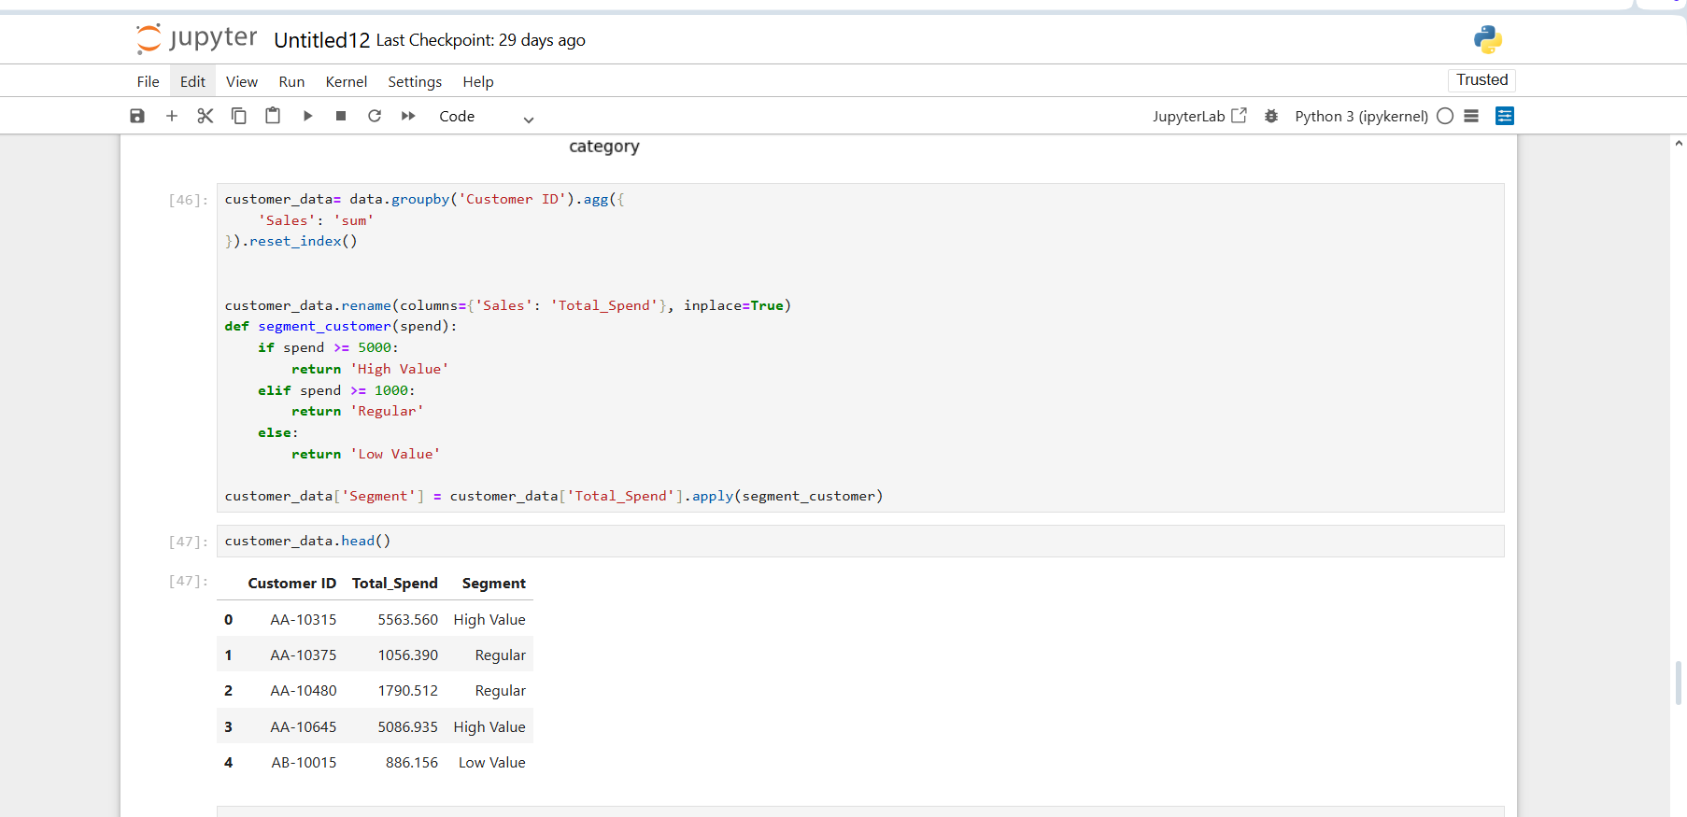
4. Insights
- Top 10% of customers contribute ~60% of total revenue.
- Seasonal spikes in orders (analyze by month/quarter).
